**Day 7: Semantic HTML - Writing Meaningful Code 🧠**

**What is Semantic HTML?**

Imagine you have two containers. One is just a plain box, and the other is a box with a "First Aid Kit" label on it. Both can hold the same items, but the labeled box tells you exactly what its contents are for.

That's the difference between non-semantic and semantic HTML.

* **Non-semantic element**: <div>, <span>. These are like plain boxes. They tell you nothing about their content. <div> is a block-level generic container, and <span> is an inline generic container.
* **Semantic element**: <header>, <article>, <footer>. These are like labeled boxes. They clearly define their content's role on the page.

**Why Should We Use Semantic HTML?**

Using semantic tags is crucial for modern web development for several key reasons:

1. **Accessibility ♿**: Screen readers and other assistive technologies use these tags to understand and navigate a webpage. A screen reader can tell a user, "Here is the main navigation" or "Here is the main content," allowing them to easily jump between sections. A page made only of <div>s is like a flat, featureless document.
2. **SEO (Search Engine Optimization) 📈**: Search engines like Google and Bing use crawlers to "read" your website. Semantic tags provide clear signals about the structure and importance of your content, which can help your site rank better in search results.
3. **Maintainability 🛠️**: For you and other developers, semantic HTML makes the code much easier to read and understand. When you see a <nav> tag, you instantly know you're looking at the site's navigation links, without needing to inspect its styling or content.
4. **Clarity**: It describes the purpose of the element to both the browser and the developer.

**Key Semantic Elements for Page Layout**

Let's replace our generic <div> containers with a professional, semantic structure.

* **<header>**: Represents introductory content for the entire page or a section. This is the perfect place for a logo, the main site title, and the primary navigation.
* **<nav>**: Used specifically for major navigation links. This could be the main menu at the top of your site or a table of contents.
* **<main>**: This is for the **main, unique content** of your page. There should only be **one** <main> element per page. It shouldn't contain content that's repeated across pages, like headers, footers, or sidebars.
* **<article>**: Represents a self-contained piece of content that could, in theory, be distributed and reused independently. Think of a blog post, a news story, a forum post, or a product on a store page.
* **<section>**: A thematic grouping of content. It's a way to break up a long page into logical parts. Each <section> should ideally have a heading (<h1>-<h6>) to identify it. For example, on an "About Us" page, you might have sections for "Our History," "Our Team," and "Our Mission."
* **<aside>**: Represents content that is tangentially related to the main content around it. This is often used for sidebars containing things like related links, a glossary of terms, or author bios.
* **<footer>**: Represents the footer for the entire page or a section. It typically contains information like copyright notices, contact information, and links to privacy policies.

The primary difference is their display behavior: a **<div> is a block-level element** used for grouping larger sections of content, while a **<span> is an inline element** used for styling a small part of text within a line.

Think of it this way: a <div> is like a large cardboard **box 📦** for organizing items, while a <span> is like a **highlighter pen ✒️** for marking a specific word.

**The <div> Tag (Division)**

The <div> tag is a generic container used to group together other HTML elements into a block-level section. It's one of the most commonly used tags for creating page layouts.

* **Behavior**: **Block-level**. This means it always starts on a new line and takes up the full width available to it, pushing other elements below it.
* **Purpose**: To group large chunks of content (like a header, a product card, or a user profile section) so you can apply CSS styles or JavaScript logic to that entire section at once.
* **Analogy**: A storage box. It holds various items together and separates them from other boxes.

**The <span> Tag**

The <span> tag is a generic inline container used to group a small piece of content, typically text, *within* a larger element.

* **Behavior**: **Inline**. This means it does *not* start on a new line and only takes up as much width as its content requires.
* **Purpose**: To target and apply styles to a specific word or phrase inside a line of text without disrupting the flow of the content.
* 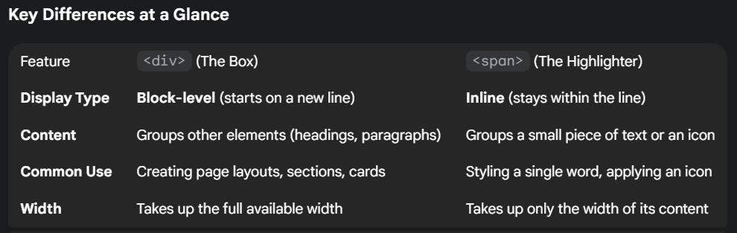**Analogy**: A highlighter pen. It marks a part of the text without forcing the sentence to break onto a new line.